Summary
Digital wallets are projected to become the dominant financial interface globally, with user adoption expected to grow from 4.3 billion in 2024 to nearly 6 billion by 2030. Transaction volumes will surge from $10 trillion to $17 trillion by 2029, driven by contactless payments, Open Banking, and financial inclusion. Integration of digital assets like stablecoins will enable real-time global payments, while AI will enhance fraud detection, personalization, and user experience. Regulatory frameworks such as the EU's MiCA and U.S. GENIUS Act will shape compliance and consumer protection. Over the next decade, digital wallets will evolve into comprehensive financial ecosystems.

Introduction
Digital wallets have transformed from niche payment tools into mainstream financial instruments, enabling billions of users to transact seamlessly across borders. As global commerce digitizes and consumer expectations evolve, digital wallets are positioned to become central hubs for financial activity. This paper explores the next decade of digital wallet evolution, focusing on adoption trends, integration of digital assets such as cryptocurrencies and stablecoins, the role of artificial intelligence (AI), and regulatory frameworks shaping the industry.
Thesis: Over the next decade, digital wallets will evolve into comprehensive financial ecosystems, driven by rapid adoption, AI-powered personalization and security, integration of digital assets, and transformative regulatory frameworks that balance innovation with consumer protection.

The 10-Year Outlook for Digital Wallets
The global adoption of digital wallets is accelerating at an unprecedented pace. Digital wallets are increasingly the primary consumer interface for financial activity (payments, P2P, credit, loyalty, data). These include players such as Cash App, Venmo, Apple Wallet and merchant-wallet ecosystems. According to industry projections, the number of digital wallet users will grow from 4.3 billion in 2024 to nearly 6 billion by 2030, representing a 70% increase (Juniper Research, 2024). Transaction volumes are expected to rise from $10 trillion in 2024 to $17 trillion by 2029, underscoring their growing role in global commerce (Statista, 2024). Market size estimates suggest that the digital wallet industry will expand from $47.5 billion in 2024 to $119 billion by 2029, with a compound annual growth rate (CAGR) of 20.4% (MarketsandMarkets, 2024). Key drivers include contactless payment technologies, QR code adoption, Open Banking initiatives, and financial inclusion efforts in emerging markets. The race is on for control of the wallet interface, which means control over consumer payments flow, data, loyalty networks and embedded financial services. Banks, fintechs, big tech and merchants are competing. Wallets can capture user/data flows (transaction receipts, SKU-level merchant data, behaviors) which become valuable for analytics, lending, loyalty and ecosystem building. Ultimately, financial institutions must decide whether to partner, embed or build out their own wallet strategy (TSYS, 2025).

Digital Assets in Wallets: Cryptocurrencies, Stablecoins, and Beyond
The integration of digital assets into wallets represents a transformative shift in global financial infrastructure. Initially dominated by cryptocurrencies such as Bitcoin and Ethereum, the ecosystem has expanded to include stablecoins, central bank digital currencies (CBDCs), and tokenized deposits, each serving distinct roles in payment systems and financial markets.
Stablecoins, with a market capitalization exceeding $250 billion, have become a cornerstone of decentralized finance (DeFi) and cross-border payments (CoinMarketCap, 2024). Their value proposition lies in price stability, achieved through fiat-backed reserves or algorithmic mechanisms, enabling real-time settlement and reducing transaction costs. Use cases span remittances, treasury management, and instant peer-to-peer transfers, compressing settlement times from days to mere seconds (Circle, 2024). However, regulatory scrutiny is intensifying, with frameworks such as the GENIUS Act mandating reserve audits, AML/KYC compliance, and issuer licensing (U.S. Congress, 2025).
Beyond stablecoins, CBDCs are emerging as a pivotal innovation. Issued by central banks, CBDCs aim to combine the efficiency of digital payments with the trust and stability of sovereign currency. Pilot programs in the EU, China, and several emerging markets demonstrate CBDCs’ potential to enhance financial inclusion, reduce systemic risk, and enable programmable monetary policy (BIS, 2024). Wallets integrating CBDCs will require robust privacy safeguards, interoperability standards, and cybersecurity protocols, as outlined in BIS and IMF guidance (IMF, 2024).
Tokenized deposits represent another frontier, allowing commercial banks to issue blockchain-based representations of traditional deposits. These instruments promise instant settlement and improved liquidity management while remaining within regulated banking frameworks (McKinsey, 2024). Similarly, digital securities and real-world asset tokens—such as tokenized bonds or commodities—are gaining traction, offering fractional ownership and enhanced market access.
Despite these opportunities, challenges persist. Cryptocurrencies remain highly volatile, limiting their utility as a medium of exchange. Regulatory uncertainty around custody, taxation, and cross-border compliance adds complexity for wallet providers. Furthermore, integrating diverse asset classes into a single wallet demands advanced risk management, smart contract auditing, and regulatory reporting capabilities.
In summary, the future of digital wallets will extend far beyond simple payment functionality. By incorporating stablecoins, CBDCs, tokenized deposits, and other digital assets, wallets are poised to become comprehensive financial platforms. Success will hinge on balancing innovation with compliance, security, and user trust.

AI’s Impact on Digital Wallets
Artificial intelligence is redefining the capabilities of digital wallets. AI-driven fraud detection systems now achieve 96% accuracy, significantly outperforming traditional rule-based methods (Finextra, 2024). Beyond security, AI enables hyper-personalization, offering predictive budgeting tools, tailored promotions, and financial insights based on user behavior (McKinsey, 2024). Conversational interfaces powered by natural language processing (NLP) allow users to manage wallets via voice or text, improving accessibility and user experience (TechCrunch, 2024). Looking ahead, AI-powered wallets will act as financial assistants, automating portfolio management, optimizing spending, and providing real-time alerts for risk mitigation.

Regulatory Transformation
Regulation will play a decisive role in shaping the future of digital wallets. In the United States, legislative initiatives such as the GENIUS Act impose AML/KYC requirements on stablecoin issuers, treating them as financial institutions (U.S. Congress, 2025). Other proposals, including the Digital Asset Market Clarity Act and the Responsible Financial Innovation Act, aim to create a unified framework for crypto and wallet providers (CoinDesk, 2025). Globally, the European Union’s Markets in Crypto-Assets (MiCA) regulation sets harmonized compliance standards for crypto-assets, while jurisdictions like Singapore and the UAE are pioneering frameworks that integrate DeFi into mainstream finance (European Commission, 2024). Consumer protection remains a priority, with agencies like the CFPB proposing oversight for wallet providers to mitigate risks such as scams, hacking, and lack of FDIC insurance (CFPB, 2024).

Adapting to Regulatory Change: Strategic Imperatives
As regulatory frameworks for digital wallets and digital assets evolve, financial institutions and fintech companies face a critical need to adapt their operating models. The upcoming CFPB rule, which brings large nonbank wallet providers under supervisory authority, and global initiatives such as EU PSD3 and MiCA, signal a shift toward heightened compliance and consumer protection standards (CFPB, 2024; European Commission, 2024). To remain competitive and compliant, organizations must pursue a multi-pronged strategy.
First, compliance readiness is paramount. Institutions should invest in automated AML/KYC onboarding and real-time transaction monitoring to meet requirements under the GENIUS Act and similar stablecoin regulations mandating reserve attestations and regulated issuance (U.S. Congress, 2025). Building dedicated compliance teams and deploying AI-driven tools can reduce operational risk while ensuring adherence to evolving standards.
Second, technology modernization is essential. Wallet architectures must support interoperability and instant payments to align with PSD3 and CBDC frameworks emphasizing 24/7 settlement and cross-border compatibility (European Commission, 2024; BIS, 2024). Adopting ISO 20022 messaging and integrating CBDC-ready APIs will position firms for future-proof operations.
Third, digital asset integration offers both opportunity and complexity. Banks and fintechs should explore regulated custody solutions and tokenization platforms to enable stablecoin issuance and programmable payments, addressing requirements under the STABLE Act and MiCA (European Commission, 2024; U.S. Congress, 2025). These capabilities will unlock new revenue streams while mitigating compliance risk.
Fourth, robust risk and governance frameworks are critical. With the CLARITY Act and global crypto regulations defining boundaries for DeFi and digital assets, institutions must implement risk scoring models, smart contract audits, and regulatory reporting dashboards to maintain trust and transparency (CoinDesk, 2025).
Finally, consumer protection and user experience should remain central. Embedding real-time fraud alerts, transparent disclosures, and insurance mechanisms within wallets will satisfy CFPB and EU mandates while enhancing customer confidence (CFPB, 2024; European Commission, 2024).
Strategic partnerships with regulators, technology providers, and industry consortiums will further accelerate compliance and innovation. Participation in regulatory sandboxes and CBDC pilots can provide early insights and influence policy development (BIS, 2024).
In sum, adapting to regulatory change requires a holistic approach encompassing compliance, technology, risk management, and customer-centric design. Institutions that act proactively will not only mitigate regulatory risk but also position themselves as leaders in the next generation of digital financial services.

Conclusion
Digital wallets are on the cusp of becoming multi-functional financial platforms, integrating payments, investments, and digital assets under a single interface. AI will enhance security and personalization, while regulatory clarity will foster trust and stability. For consumers, this evolution promises convenience and empowerment; for businesses, new revenue streams; and for regulators, a balancing act between innovation and risk mitigation. Future research should explore interoperability, central bank digital currencies, and privacy concerns as digital wallets become ubiquitous.

References
- Juniper Research. (2024). Digital Wallet Adoption Forecasts.
- Statista. (2024). Global Digital Wallet Transaction Volume.
- MarketsandMarkets. (2024). Digital Wallet Market Size and Growth.
- TSYS. (2025). Is it finally showtime for open banking in the United States?
- CoinMarketCap. (2024). Stablecoin Market Capitalization.
- Circle. (2024). Stablecoin Use Cases in Payments.
- U.S. Congress. (2025). GENIUS Act Legislative Summary.
- BIS. (2024). CBDC Interoperability Framework.
- IMF. (2024). CBDC Design Principles.
- McKinsey & Company. (2024). Tokenized Deposits and Digital Asset Strategy.
- Finextra. (2024). AI in Fraud Detection for Digital Payments.
- McKinsey & Company. (2024). AI and Personalization in Financial Services.
- TechCrunch. (2024). Conversational AI in Digital Wallets.
- U.S. Congress. (2025). GENIUS Act Legislative Summary.
- European Commission. (2024). Markets in Crypto-Assets Regulation.
- CFPB. (2024). Consumer Protection in Digital Wallets.
- European Commission. (2024). Markets in Crypto-Assets Regulation.
- BIS. (2024). CBDC Interoperability Framework.
- U.S. Congress. (2025). GENIUS Act Legislative Summary.
- CoinDesk. (2025). CLARITY Act and Crypto Regulation.
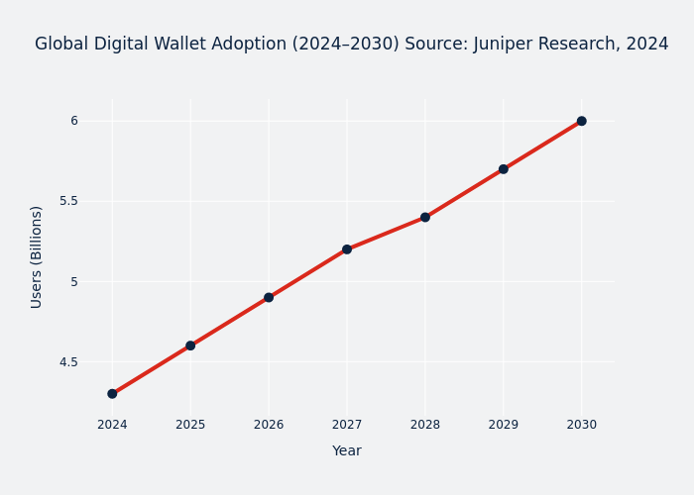
Global Digital Wallet Adoption (2024–2030)
Source: Juniper Research, 2024
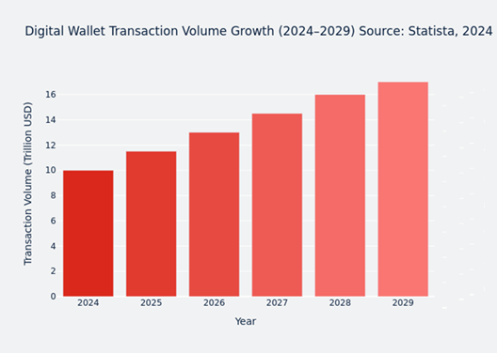
Digital Wallet Transaction Volume Growth (2024–2029)
Source: Statista, 2024
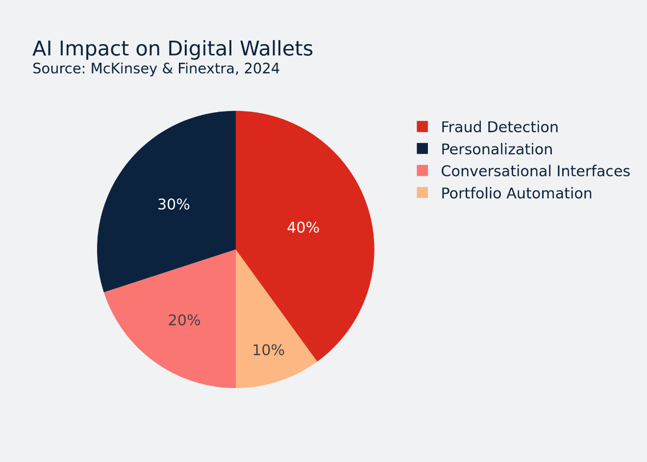
AI Impact on Digital Wallets
Source: McKinsey & Finextra, 2024

